Homemade Barometer

Subject:  Related Subjects: | Grade Level(s):  Length of Lesson: | Type: Inquiry / Design / Project  Keywords:

Lesson Overview
Use this section to describe at a high level what the lesson is. Should be no more than 3-4 lines.

Lesson Focus
What is the central question or phenomenon being investigated? What problem are they trying to solve?

Lesson Objective(s) | By the end of this lesson, students will…  - Learn the concepts of attraction, repulsion, friction, polarity, and charge.

Lesson Timing

5 minutes | Introduce the Lesson
30 minutes | ...

Materials | - Material 1 (# per student, per group of # students, per class)
Instructor Prep | - Step 1
Related Resources | - List related lessons/ppts etc available from USC or outside, trusted orgs

Lesson Plan

Introduction
Introduce students to the learning goals and make connections to past and present learning experiences. Stimulate interest and prompt students to identify their own questions about the topic. This can link the lesson to real world examples, introduce associated STEM careers, and assess their prior knowledge on the topic.

- Step 1

Procedure

Experiment-1
- Fill the measuring cup or glass with water and add some colored dye to it.
- Flip the empty soda bottle upside down into the glass measuring cup.
- Assure that you use a bottle that is just the right size. It should fit snugly in the measuring cup so that the mouth of the bottle does not touch the bottom of the cup.
- Assure that the level of the water extends into the neck of the bottle.
- Mark a line on the cup to indicate the water level within the bottle.
- Reexamine the bottle in a few days.
Experiment-2
- Take a large Mason jar and seal the opening with a balloon stretched over it snug, but not TOO tight (We used to use glass milk bottles, but who's seen those in a while? ;)
- Glue a matchstick into the end of a drinking straw.
- Glue the other end of the drinking straw to the center of the balloon (This is your "Pointer" and the matchstick is the "point"). The MatchStick is used as "Weight" on the end of the straw and, as noted above, as your pointer.
- Make a cardboard chart showing Pressure.
- Place the jar somewhere permanent like a counter top and place the cardboard "chart" on the wall in front of the "Pointer".
- Turn on the local weather channel and find out what the barometer reading for your area is "right now" and mark it on the chart where the "pointer" (the straw with a matchstick tip)is pointing...
- Over the next several days, find out what the barometer reading is from the local weather channel and mark those readings on your chart where the matchstick is pointing...
- You can also use this in your saferoom to measure you positive pressure... simply mark on the chart the starting point, pressurize the room till you feel comfortable, and the matchstick tip should have risen some.. mark that spot as "goal pressure".
- As the pressure inside the room builds, it pushes down on the top of the jar causing the balloon to sink in which makes the pointer glued to it rise..

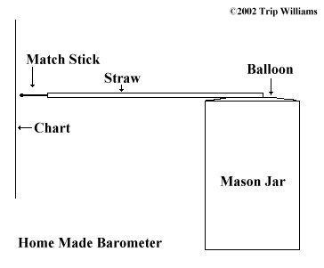
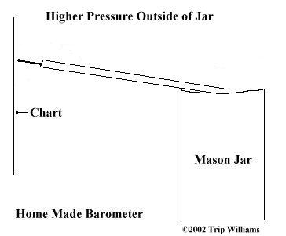
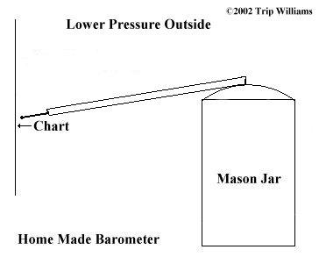

Wrap-up
Notice the change in the water level? The amount of air within the bottle is fixed and cannot change since the water extended into the bottle acts as a 'plug'. Hence, you can consider the amount of air trapped in the bottle as an indicator of the air pressure on the day you plugged the bottle. The pressure on the surface of the water depends on the current air pressure. When the air pressure increases (as it does in drier weather), the pressure on the surface of the water is greater and the water is forced up into the bottle changing the level of the water. If you see the water level drop, look for your umbrella...

Lesson Background for Teachers

Suggested Real-World STEM Connections
- List possible related Role Models in STEM (with details and links to more reading). Give suggestions for examples of scientists/engineers who are from underrepresented groups in STEM in related careers.
- List related real-world engineering problems and examples

Lesson Variations and Options
Include descriptions of alternative methods or ways to present things.

Explanation
Describe the background concepts and explanations behind the lesson. This can be more in depth than a teacher/instructor would actually share with students.

Key Concepts and Vocabulary
- Word 1: Grade Appropriate Definition
- Word 2: Grade Appropriate Definition

Safety Notes
- Safety instruction

